**What is jQuery?**

jQuery is a lightweight, "write less, do more", JavaScript library.

The purpose of jQuery is to make it much easier to use JavaScript on your website.

jQuery takes a lot of common tasks that require many lines of JavaScript code to accomplish, and wraps them into methods that you can call with a single line of code.

jQuery also simplifies a lot of the complicated things from JavaScript, like AJAX calls and DOM manipulation.

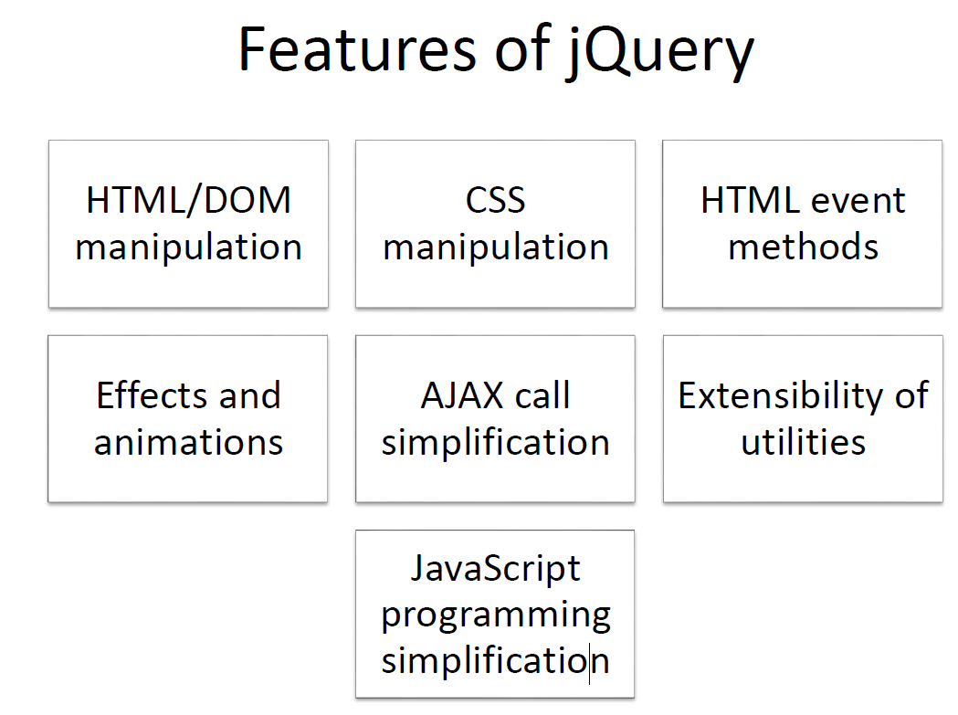

**Why jQuery?**

There are lots of other JavaScript libraries out there, but jQuery is probably the most popular, and also the most extendable.

Many of the biggest companies on the Web use jQuery, such as:

* Google
* Microsoft
* IBM
* Netflix

**Adding jQuery to Your Web Pages**

There are several ways to start using jQuery on your web site. You can:

* Download the jQuery library from jQuery.com
* Include jQuery from a content delivery network (CDN), like Google

## Downloading jQuery

There are two versions of jQuery available for downloading:

* Production version - this is for your live website because it has been minified and compressed
* Development version - this is for testing and development (uncompressed and readable code)

Both versions can be downloaded from [jQuery.com](http://jquery.com/download/" \t "_blank).

The jQuery library is a single JavaScript file, and you reference it with the HTML <script> tag (notice that the <script> tag should be inside the <head> section):

<head>  
<script src="jquery-3.7.1.min.js"></script>  
</head>

## jQuery CDN

If you don't want to download and host jQuery yourself, you can include it from a CDN (Content Delivery Network).

Google is an example of someone who host jQuery:

### **Google CDN:**

<head>  
<script src="https://ajax.googleapis.com/ajax/libs/jquery/3.7.1/jquery.min.js"></script>  
</head>

## jQuery Syntax

The jQuery syntax is tailor-made for **selecting** HTML elements and performing some **action** on the element(s).

Basic syntax is: **$(*selector*).*action*()**

* A $ sign to define/access jQuery
* A (*selector*) to "query (or find)" HTML elements
* A jQuery *action*() to be performed on the element(s)

Examples:

$(this).hide() - hides the current element.

$("p").hide() - hides all <p> elements.

$(".test").hide() - hides all elements with class="test".

$("#test").hide() - hides the element with id="test".

## The Document Ready Event

You might have noticed that all jQuery methods in our examples, are inside a document ready event:

$(document).ready(function(){  
  
  *// jQuery methods go here...*  
  
});

This is to prevent any jQuery code from running before the document is finished loading (is ready).

It is good practice to wait for the document to be fully loaded and ready before working with it. This also allows you to have your JavaScript code before the body of your document, in the head section.

Here are some examples of actions that can fail if methods are run before the document is fully loaded:

* Trying to hide an element that is not created yet
* Trying to get the size of an image that is not loaded yet

**Tip:** The jQuery team has also created an even shorter method for the document ready event:

$(function(){  
  
  *// jQuery methods go here...*  
  
});

Use the syntax you prefer. We think that the document ready event is easier to understand when reading the code.

## jQuery Selectors

jQuery selectors allow you to select and manipulate HTML element(s).

jQuery selectors are used to "find" (or select) HTML elements based on their name, id, classes, types, attributes, values of attributes and much more. It's based on the existing [CSS Selectors](https://www.w3schools.com/cssref/css_selectors.asp), and in addition, it has some own custom selectors.

All selectors in jQuery start with the dollar sign and parentheses: $().

## The element Selector

The jQuery element selector selects elements based on the element name.

You can select all <p> elements on a page like this:

$("p")

**Example**

When a user clicks on a button, all <p> elements will be hidden:

<head>

<script src="https://ajax.googleapis.com/ajax/libs/jquery/3.7.1/jquery.min.js"></script>

<script>

$(document).ready(function(){

$("button").click(function(){

$("p").hide();

});

});

</script>

</head>

<body>

<h2>This is a heading</h2>

<p>This is a paragraph.</p>

<p>This is another paragraph.</p>

<button>Click me to hide paragraphs</button>

</body>

**The #id Selector**

The jQuery #*id* selector uses the id attribute of an HTML tag to find the specific element.

An id should be unique within a page, so you should use the #id selector when you want to find a single, unique element.

To find an element with a specific id, write a hash character, followed by the id of the HTML element:

$("#test")

**Example**

When a user clicks on a button, the element with id="test" will be hidden:

<head>

<script src="https://ajax.googleapis.com/ajax/libs/jquery/3.7.1/jquery.min.js"></script>

<script>

$(document).ready(function(){

$("button").click(function(){

$("#test").hide();

});

});

</script>

</head>

<body>

<h2>This is a heading</h2>

<p>This is a paragraph.</p>

<p id="test">This is another paragraph.</p>

<button>Click me</button>

</body>

**The .class Selector**

The jQuery *.class* selector finds elements with a specific class.

To find elements with a specific class, write a period character, followed by the name of the class:

$(".test")

**Example**

When a user clicks on a button, the elements with class="test" will be hidden:

<head>

<script src="https://ajax.googleapis.com/ajax/libs/jquery/3.7.1/jquery.min.js"></script>

<script>

$(document).ready(function(){

$("button").click(function(){

$(".test").hide();

});

});

</script>

</head>

<body>

<h2 class="test">This is a heading</h2>

<p class="test">This is a paragraph.</p>

<p>This is another paragraph.</p>

<button>Click me</button>

</body>

More Examples of jQuery Selectors

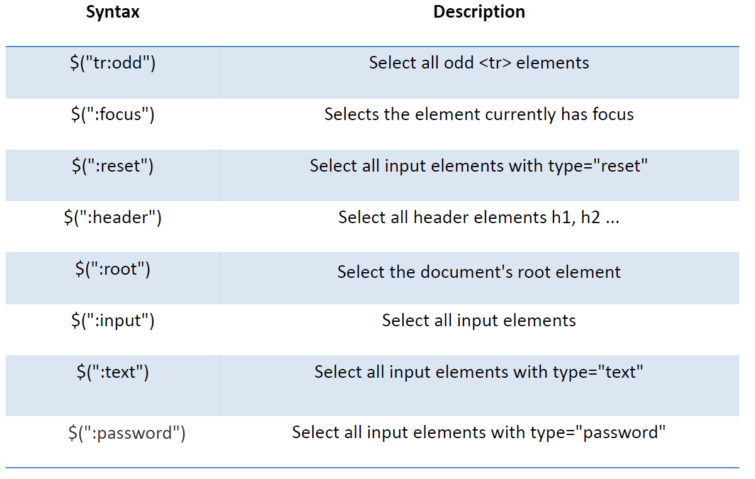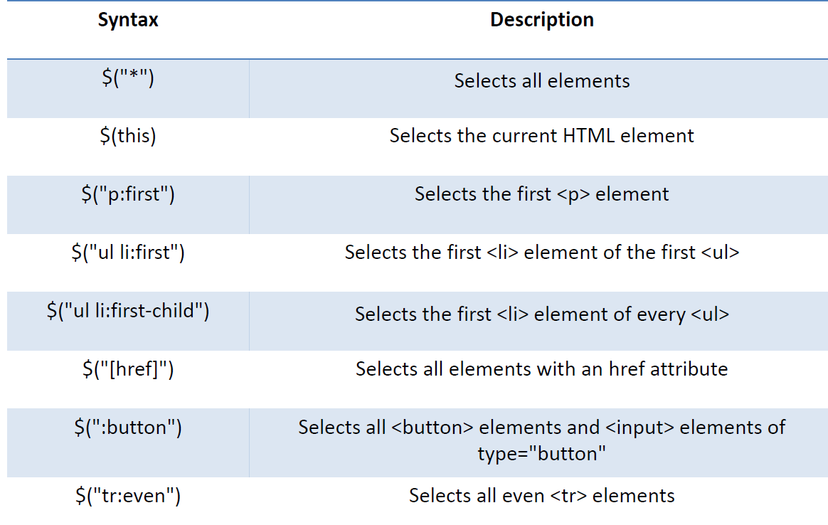

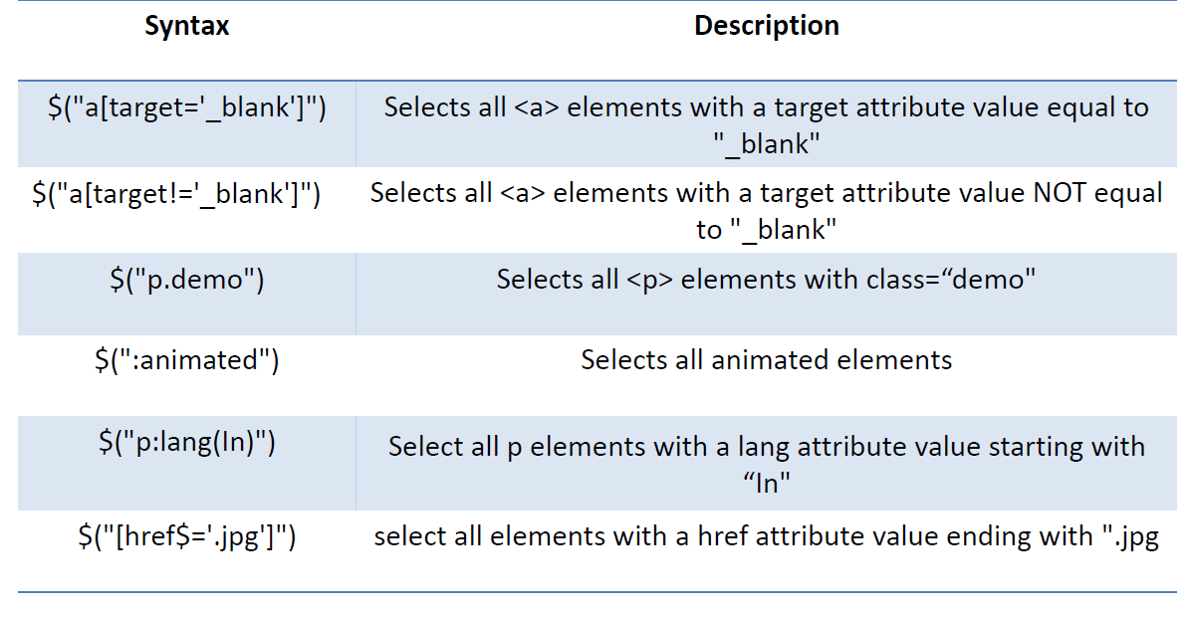

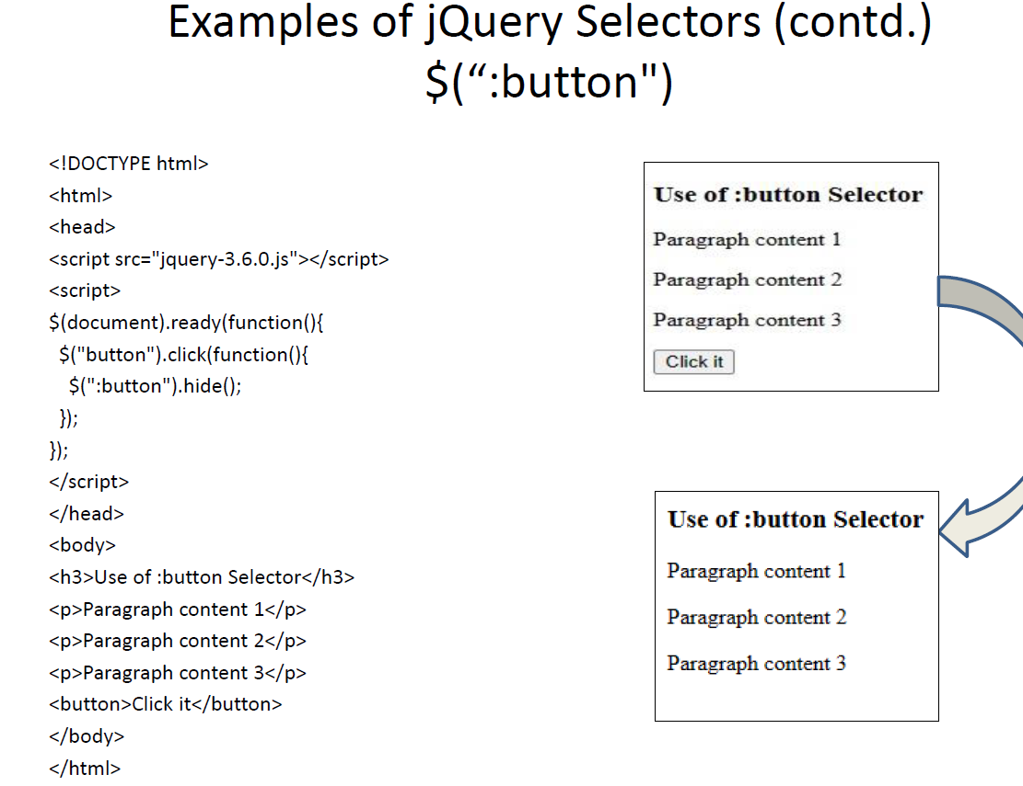

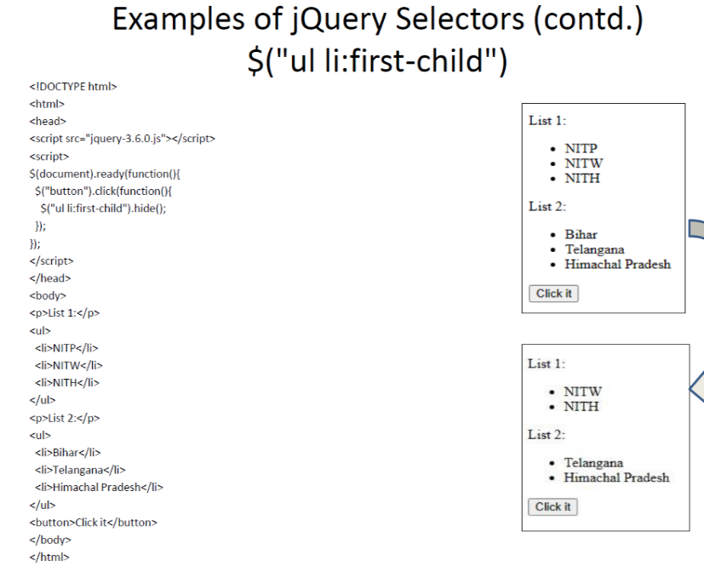

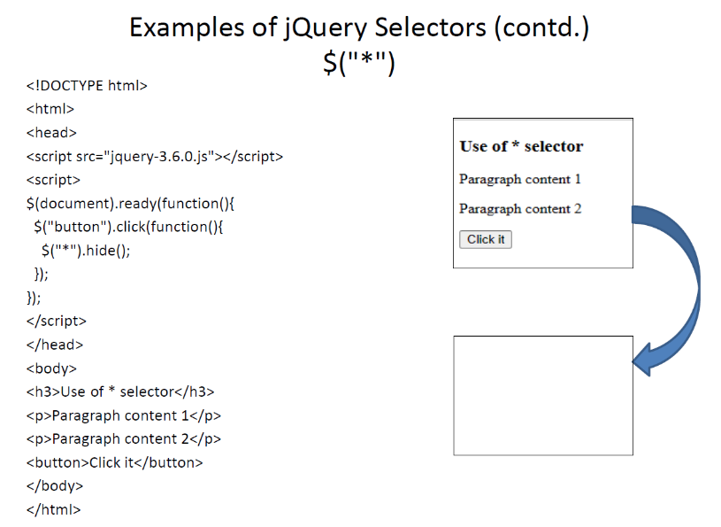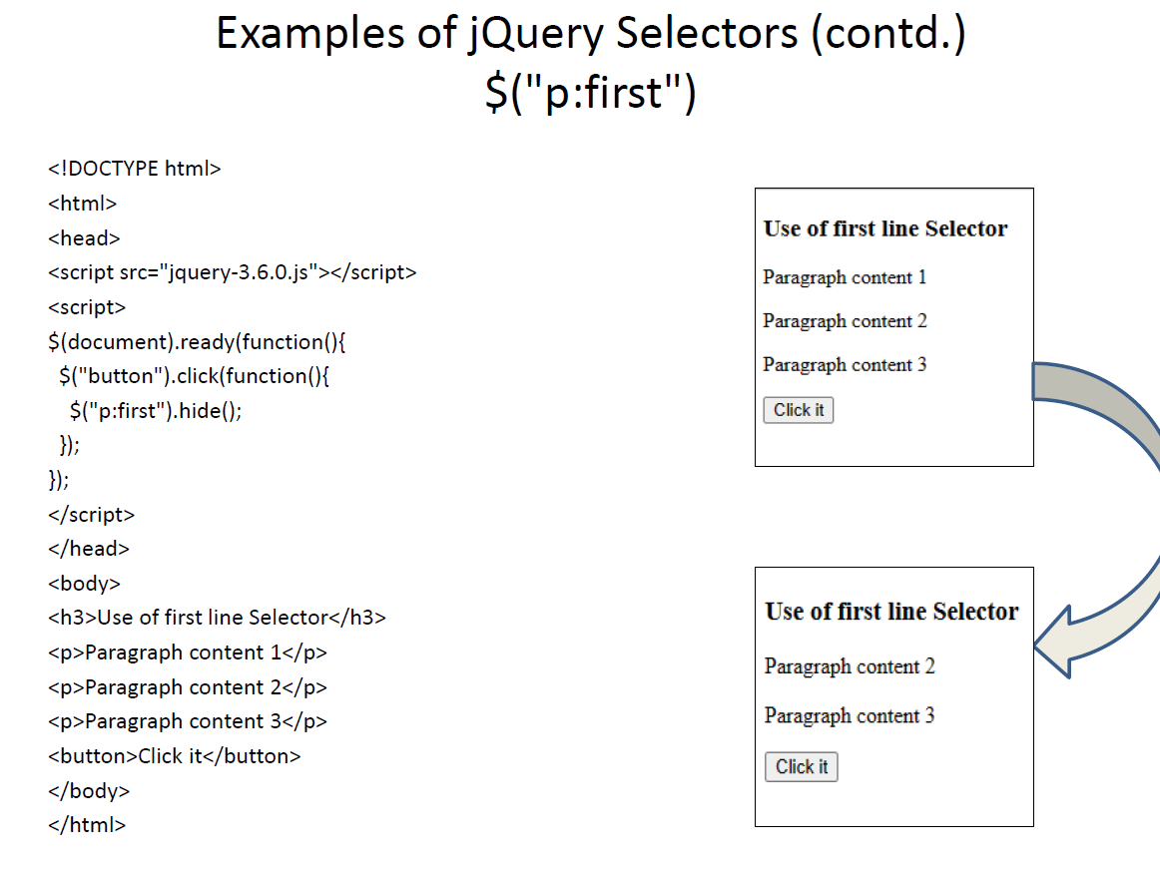

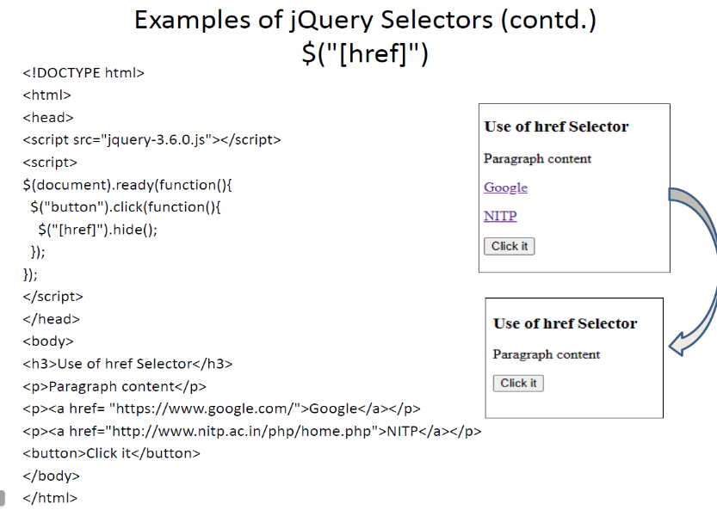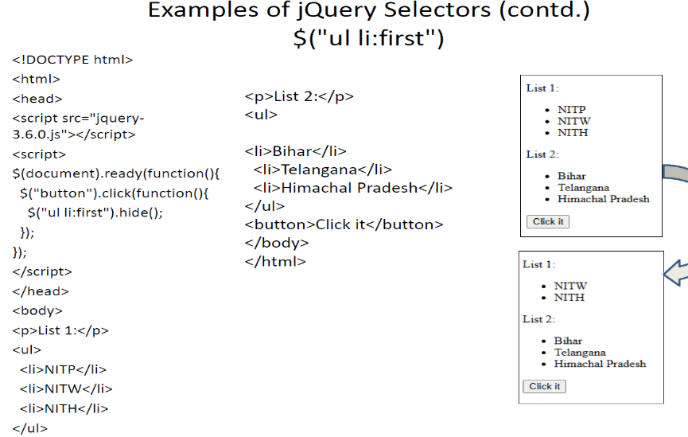

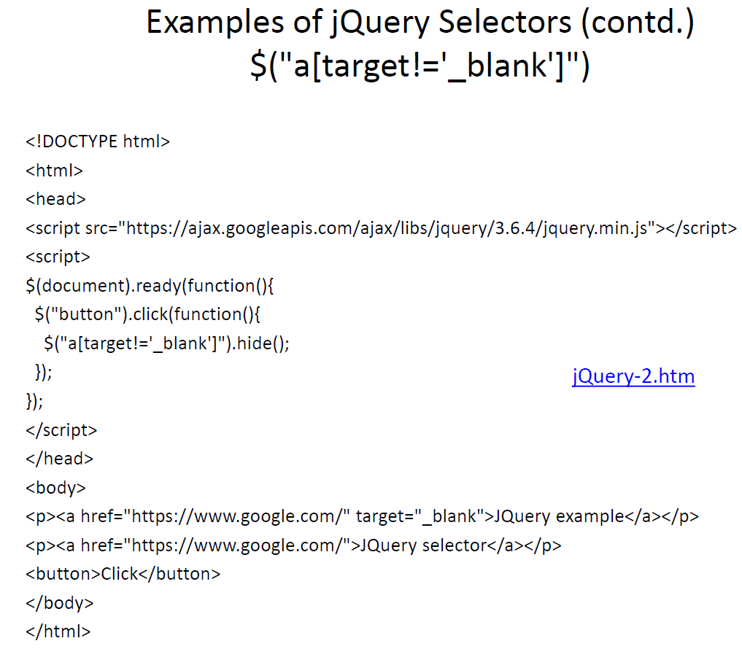

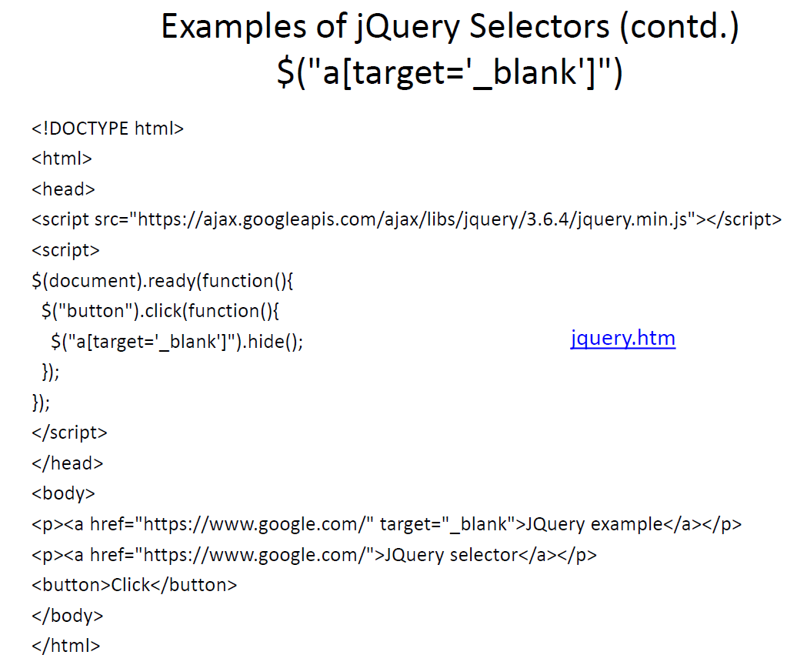

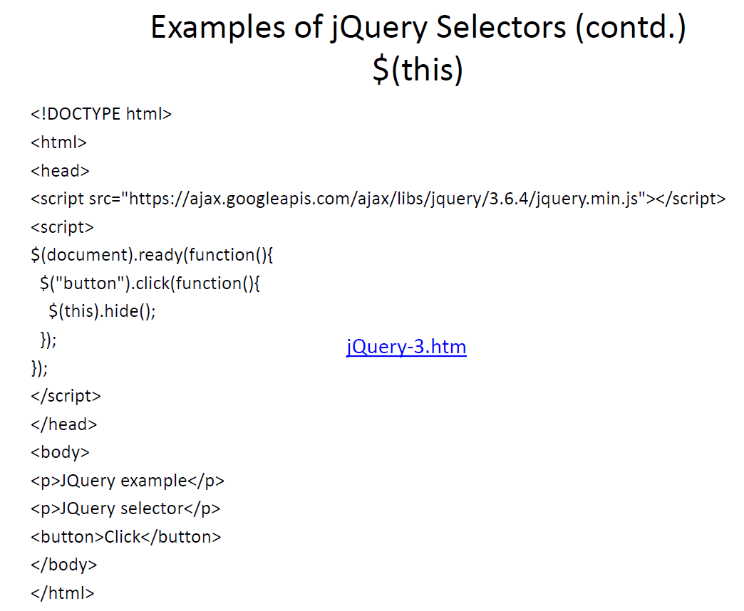

**mouseenter()**

The mouseenter() method attaches an event handler function to an HTML element.

The function is executed when the mouse pointer enters the HTML element:

$("#p1").mouseenter(function(){  
  alert("You entered p1!");  
});

<p id="p1">Enter this paragraph.</p>

**mouseleave()**

The mouseleave() method attaches an event handler function to an HTML element.

The function is executed when the mouse pointer leaves the HTML element:

### **Example**

$("#p1").mouseleave(function(){  
  alert("Bye! You now leave p1!");  
});

**mousedown()**

The mousedown() method attaches an event handler function to an HTML element.

The function is executed, when the left, middle or right mouse button is pressed down, while the mouse is over the HTML element:

### **Example**

$("#p1").mousedown(function(){  
  alert("Mouse down over p1!");  
});

**mouseup()**

The mouseup() method attaches an event handler function to an HTML element.

The function is executed, when the left, middle or right mouse button is released, while the mouse is over the HTML element:

$("#p1").mouseup(function(){  
  alert("Mouse up over p1!");  
});

**On()**

Attach multiple event handlers to a <p> element:

<script>

$(document).ready(function(){

$("p").on({

mouseenter: function(){

$(this).css("background-color", "lightgray");

},

mouseleave: function(){

$(this).css("background-color", "lightblue");

},

click: function(){

$(this).css("background-color", "yellow");

}

});

});

</script>

<p>Click or move the mouse pointer over this paragraph.</p>

## jQuery fadeIn() Method

The jQuery fadeIn() method is used to fade in a hidden element.

**Syntax:**

$(*selector*).fadeIn(*speed,callback*);

The optional speed parameter specifies the duration of the effect. It can take the following values: "slow", "fast", or milliseconds.

The optional callback parameter is a function to be executed after the fading completes.

The following example demonstrates the fadeIn() method with different parameters:

$("button").click(function(){  
  $("#div1").fadeIn();  
  $("#div2").fadeIn("slow");  
  $("#div3").fadeIn(3000);  
});

## jQuery fadeOut() Method

The jQuery fadeOut() method is used to fade out a visible element

$("button").click(function(){  
  $("#div1").fadeOut();  
  $("#div2").fadeOut("slow");  
  $("#div3").fadeOut(3000);  
});

## jQuery fadeToggle() Method

The jQuery fadeToggle() method toggles between the fadeIn() and fadeOut() methods.

If the elements are faded out, fadeToggle() will fade them in.

If the elements are faded in, fadeToggle() will fade them out.

$("button").click(function(){  
  $("#div1").fadeToggle();  
  $("#div2").fadeToggle("slow");  
  $("#div3").fadeToggle(3000);  
});

## jQuery fadeTo() Method

The jQuery fadeTo() method allows fading to a given opacity (value between 0 and 1).

**Syntax:**

$(*selector*).fadeTo(*speed,opacity,callback*);

The required opacity parameter in the fadeTo() method specifies fading to a given opacity (value between 0 and 1).

$("button").click(function(){  
  $("#div1").fadeTo("slow", 0.15);  
  $("#div2").fadeTo("slow", 0.4);  
  $("#div3").fadeTo("slow", 0.7);  
});

## Get Content - text(), html(), and val()

Three simple, but useful, jQuery methods for DOM manipulation are:

* text() - Sets or returns the text content of selected elements
* html() - Sets or returns the content of selected elements (including HTML markup)
* val() - Sets or returns the value of form fields

The following example demonstrates how to get content with the jQuery text() and html() methods:

$("#btn1").click(function(){  
  alert("Text: " + $("#test").text());  
});  
$("#btn2").click(function(){  
  alert("HTML: " + $("#test").html());  
});

The following example demonstrates how to get the value of an input field with the jQuery val() method:

### **Example**

$("#btn1").click(function(){  
  alert("Value: " + $("#test").val());  
});

## Get Attributes - attr()

The jQuery attr() method is used to get attribute values.

The following example demonstrates how to get the value of the href attribute in a link:

$("button").click(function(){  
  alert($("#w3s").attr("href"));  
});